Lab Programs

30. Bar Plot for Scores by Group and Gender

Aim
To write a Python program to create a bar plot of scores by group and gender using multiple Y-values on the same chart.

Algorithm
- Import the matplotlib.pyplot library.
- Create a list of groups G1 to G5.
- Store the scores of men and women.
- Set the width of each bar.
- Plot men's scores using green bars.
- Plot women's scores beside the men's bars using red bars.
- Add title, X-axis label, Y-axis label, and legend.
- Display the bar chart.

Code
import matplotlib.pyplot as plt

# Input data
groups = ['G1', 'G2', 'G3', 'G4', 'G5']
men = [22, 30, 35, 35, 26]
women = [25, 32, 30, 35, 29]

x = range(len(groups))
width = 0.35

# Plot bars
plt.bar([i - width/2 for i in x], men, width=width,
label='Men', color='green')

plt.bar([i + width/2 for i in x], women, width=width,
label='Women', color='red')

# Labels and title
plt.xlabel('Person')
plt.ylabel('Score')
plt.title('Scores by person')

plt.xticks(x, groups)
plt.legend()

plt.show()

Input
Men scores = [22, 30, 35, 35, 26]
Women scores = [25, 32, 30, 35, 29]
Groups = [G1, G2, G3, G4, G5]

Output
A grouped bar chart is displayed showing the scores of Men and Women for G1 to G5.

Result
Thus, the Python program successfully creates a grouped bar plot for the given scores by group and gender.
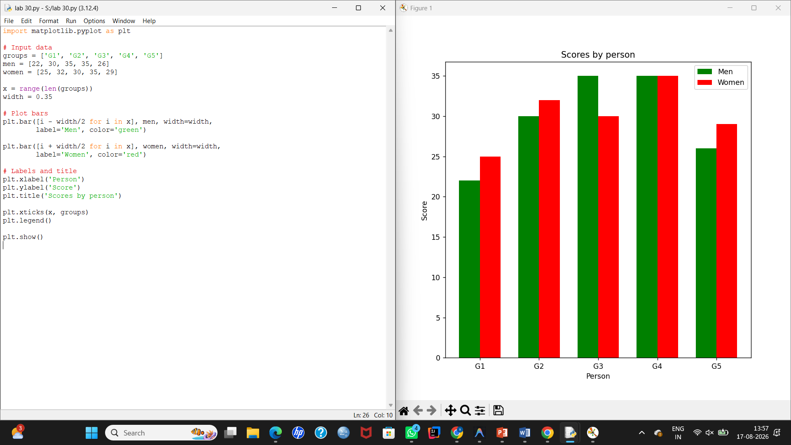

31. Stacked Bar Plot with Error Bars

Aim
To write a Python program to create a stacked bar plot with error bars, where women's bars are stacked on top of men's bars.

Algorithm
- Import matplotlib.pyplot.
- Create the group names.
- Store men's and women's mean scores.
- Store the standard deviations of men and women.
- Plot men's scores as the bottom portion of the bars with error bars.
- Plot women's scores on top of men's scores using the bottom parameter.
- Add women's error bars.
- Add title, labels, and legend.
- Display the chart.

Code
import matplotlib.pyplot as plt

# Input data
groups = ['Group1', 'Group2', 'Group3', 'Group4', 'Group5']

men = [22, 30, 35, 35, 26]
women = [25, 32, 30, 35, 29]

men_sd = [4, 3, 4, 1, 5]
women_sd = [3, 5, 2, 3, 3]

x = range(len(groups))

# Plot men's scores at the bottom
plt.bar(x, men, yerr=men_sd, capsize=5,
label='Men', color='red')

# Plot women's scores on top of men's
plt.bar(x, women, bottom=men, yerr=women_sd,
capsize=5, label='Women', color='green')

# Labels and title
plt.xlabel('Groups')
plt.ylabel('Score')
plt.title('Scores by group and gender')

plt.xticks(x, groups)
plt.legend()

plt.show()

Input
Men scores = [22, 30, 35, 35, 26]
Women scores = [25, 32, 30, 35, 29]

Men SD = [4, 3, 4, 1, 5]
Women SD = [3, 5, 2, 3, 3]

Output
A stacked bar chart is displayed where:
- Men's scores appear at the bottom.
- Women's scores appear on top of men's scores.
- Error bars show the standard deviation.

Result
Thus, the Python program successfully creates a stacked bar plot with error bars for men's and women's scores.
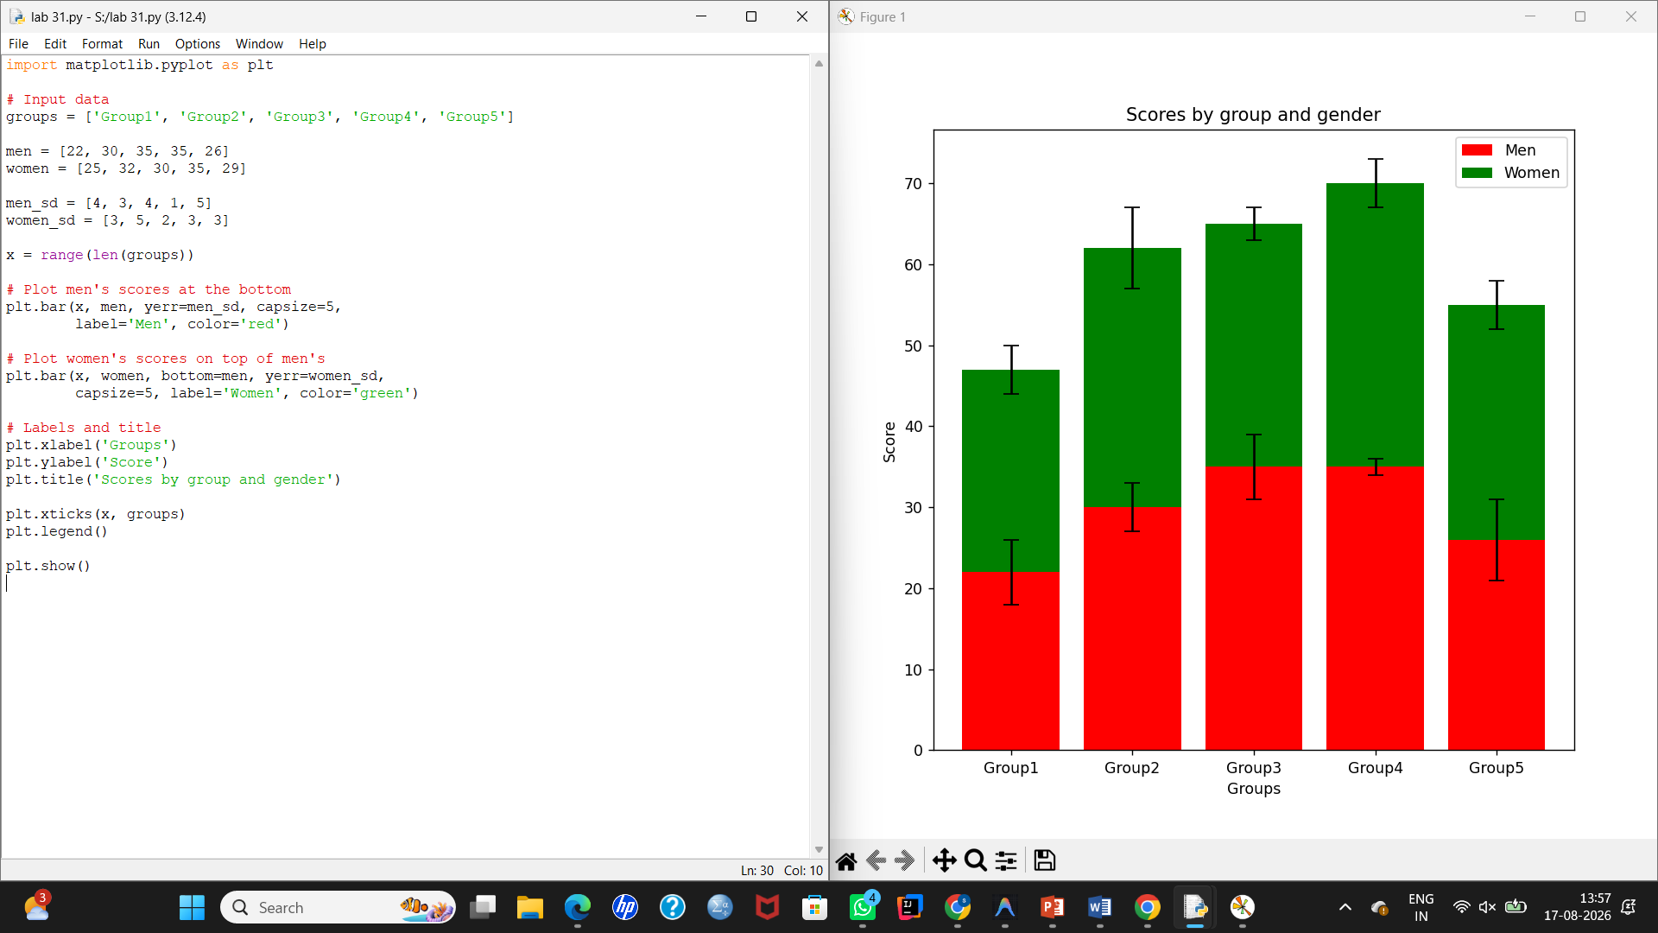

32. Scatter Plot Using Random Distribution

Aim
To write a Python program to generate random values from a normal distribution in X and Y and plot them against each other using a scatter plot.

Algorithm
- Import numpy and matplotlib.pyplot.
- Generate random values for X using a normal distribution.
- Generate random values for Y using a normal distribution.
- Plot X and Y using a scatter plot.
- Add X-axis and Y-axis labels.
- Display the graph.

Code
import numpy as np
import matplotlib.pyplot as plt

# Generate random values
np.random.seed(10)

x = np.random.normal(0, 1, 200)
y = np.random.normal(0, 1, 200)

# Create scatter plot
plt.scatter(x, y, color='red', s=10)

# Labels
plt.xlabel('X')
plt.ylabel('Y')
plt.title('Scatter Plot of Random Distribution')

plt.show()

Input
Random normal distribution values
Number of points = 200
Mean = 0
Standard deviation = 1

Output
A scatter plot is displayed with randomly distributed points around the X-Y origin.

Result
Thus, the Python program successfully generates random X and Y values and plots them against each other using a scatter graph.
